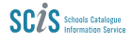
SUPPORTING INFORMATION LITERACY WITH
SCIS AUTHORITY FILES
-presentation handout-

Information literacy frameworks
Comparison table
Information literacy ability | University of Notre Dame Australia | University of Melbourne | Australian and New Zealand Information literacy framework
Recognise  - Recognise the need for information  - Identify what type of information is needed  - Understand how much information is needed | Embark and Clarify: Recognise the need for information and the nature and extent of what information is needed. |  | recognises the need for information and determines the nature and extent of the  information needed
Find  - Search for information using appropriate techniques | Find and Collect: Find and collect information or data using appropriate techniques. | search, navigate, locate | finds needed information effectively and efficiently
Organise  - Organise and manage information collected in a logical way | Manage and Communicate: Organise information and data to communicate patterns and themes, and manage research processes. | organise, manage, curate | manages information collected or generated
Evaluate  - Evaluate information and information sources to determine its credibility  - Critique information to determine its appropriateness | Evaluate and Reflect: Determine and critique the credibility of selected sources, information and data generated. | Evaluate, analyse, review | critically evaluates information and the information seeking process
Synthesise  - Synthesise prior knowledge with new information  - Create new understandings from information gathered |  | evaluate, analyse, review | applies prior and new information to construct new concepts or create new  understandings
Communicate  - Communicate understandings and information from research  - Reflect on the process | Reflect on the research processes used. | communicate, connect, share  create, collaborate, reflect

NSW Department of Education Information Fluency Framework
https://education.nsw.gov.au/content/dam/main-education/teaching-and-learning/curriculum/media/documents/Information_fluency_framework.pdf
The image below is an overview of the framework, which goes into detail about each element including how students develop skills progressively and how skills are integrated into the curriculum.
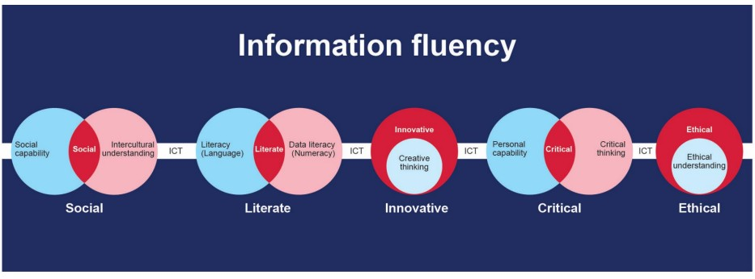

Authority Files
SCIS Help pages
https://help.scisdata.com/hc/en-us/sections/115001078128-Authority-Files
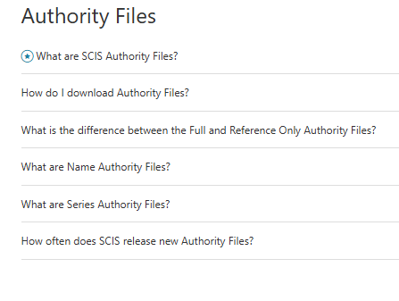

2 minute video: what are SCIS Authority Files?
https://vimeo.com/417043529?fl=pl&fe=sh
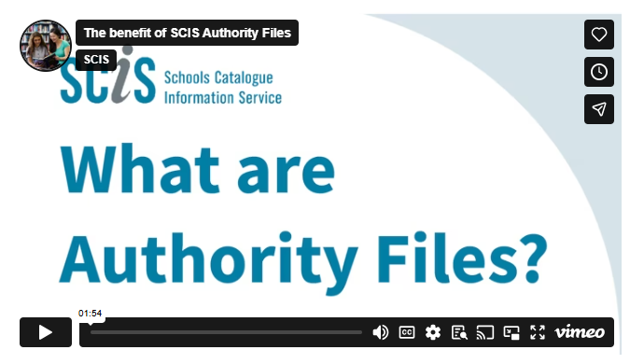

References
Ashiq, M. e. (2026). The relationship between information literacy and academic performance: a meta-analysis study. 27(1), pp. 81-97. doi:https://doi.org/10.1108/PMM-04-2025-0020
Australian Library and Information Association. (2024). Statement on school libraries and information literacy. Retrieved from Australian Library and Information Association: https://alia.org.au/common/Uploaded%20files/ALIA%20ACSL%20Statement%20on%20School%20Libraries%20and%20Information%20Literacy.pdf
Galeffi, A. e. (2017). Statement of International Cataloguing Principles. Retrieved from International Federation of Library Associations (IFLA): https://www.ifla.org/files/assets/cataloguing/icp/icp_2016-en.pdf
Goldin, H. L. (2026, February 27). Card Catalog. Retrieved from "Look it up" doesn't mean what it used to mean: Goldin, H. L. (2026, February 27). “Look it up” doesn’t mean what it used to mean [Review of “Look it up” doesn’t mean what it used to mean]. Card Catalog. https://open.substack.com/pub/cardcatalogforlife/p/look-it-up-doesnt-mean-what-it-used?utm_campaign
Grimmet, C. (2022). The information fluency framework. Connections. Retrieved from https://www.scisdata.com/connections/issue-123/the-information-fluency-framework/
Jones, C. (2013). Mining for information: an investigation into the use of computer games to develop skills in primary school aged children.
Li, F. e. (2025). The causal relationship between digital literacy and students' academic achievement: a meta-analysis. Humanities & Social Sciences Communications, 12(1). doi:https://doi.org/10.1057/s41599-025-04399-6
NSW Department of Education. (2024). Information Fluency Framework. Retrieved from https://education.nsw.gov.au/content/dam/main-education/teaching-and-learning/curriculum/media/documents/Information_fluency_framework.pdf
Sullivan, D. (2016). The lowdown on authority files. Connections(99).
University of Melbourne. (2025). Scholarly and digital capabilities framework. Retrieved from University of Melbourne Library: https://library.unimelb.edu.au/__data/assets/pdf_file/0005/4096247/University-of-Melbourne-Scholarly-and-Digital-Capabilities-Framework.pdf
University of Notre Dame Australia. (2025). Information literacy skills framework. Retrieved from The University of Notre Dame Australia Library: https://library.nd.edu.au/ld.php?content_id=51020516

